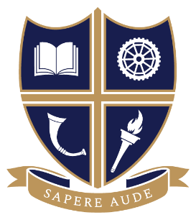
SUBJECT: BTEC Sport
EXAM BOARD: Edexcel
Course Overview (Y12) | Our BTEC Sport courses prepare you perfectly for a wide variety of careers in the health & fitness industry. They are valued by colleges, universities & employers across the World. Through studying multiple units, you’ll develop a deep understanding of sport & its application in the workplace; from psychology, personal training & physiology to nutrition, performance analysis & injury. You’ll also add vital transferrable skills to your CV like organisation, leadership, communication and team work – key skills that universities and employers look for. To compliment your breadth of experience, you’ll develop a coaching proficiency through your reserved place on the ‘Level 2 Sports Leadership Award’ course.
Useful websites | The specification can be viewed here:  https://qualifications.pearson.com/en/qualifications/btec-nationals/sport-2016.html  Useful Websites  www.btec.co.uk  http://www.topendsports.com/
Essential text books and reading list | Researching into these  topics will be beneficial:  - Anatomy & Physiology  - Health & Safety in Sport  - Fitness Testing & Health  Screening  - Government recommendations  for activity and nutrition  The revision guide is also an excellent tool to aid your revision for the unit 1 and 2 exams  https://qualifications.pearson.com/en/qualifications/btec-nationals/sport-2016.resources.html?filterQuery=category:Pearson-UK:Publisher%2FPearson

