A Level History Summer Project:
How did the Tudors become the reigning monarchs?

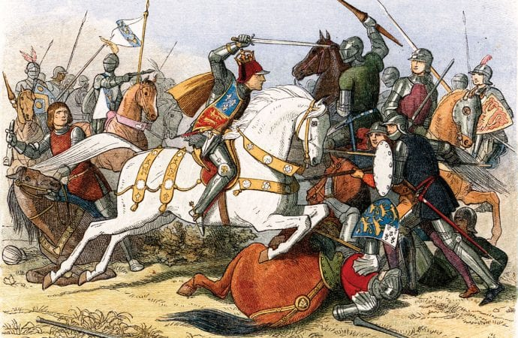

For your History A Level you will be learning 2 topics: Tudor England 1485-1603 and the Cold War 1945-1991. Your summer research task will be to look into the background of the Tudors, what life was like in Tudor England and specifically how the Tudor Dynasty came to be in power by 1485.
Below are 2 weeks worth of research projects, and a final essay to complete. Please complete them on this document or another Word Document and resubmit them to me!
Week One – The background of the Wars of the Roses
Task 1: York vs. Lancaster
- From 1455-1485 England was engaged in a series of Civil Wars between two branches of the Royal House of Plantagenet: Lancaster and York.
- The Yorkists and the Lancastrians both sought the throne of England, in a series of battles that would become known as “The Wars of the Roses” but ultimately the House of Lancaster were victorious.
- This ended with Lancastrian Henry Tudor’s victory against Yorkist Richard III at the Battle of Bosworth on 22nd August 1485, starting the Tudor dynasty becoming Henry VII.
Your task:
- Research both Richard III and Henry VII and create a fact-file on each one, including:
  - Their Houses and the symbols that represent them
  - Claim to the throne
  - Style of rule (personality, policies, government, finances)
  - Prior experience, support, allies
  - Potential enemies
  - Plans and preparation leading up to the Battle of Bosworth (army size, support, types of troop, position on the battlefield, tactics on the battlefield)
Useful Websites:
https://www.britannica.com/biography/Henry-VII-king-of-England
https://www.britannica.com/biography/Richard-III-king-of-England
https://www.historyextra.com/period/medieval/myths-facts-richard-iii-murder-princes-tower-shakespeare-york-leicester-car-park/
https://tudorhistory.org/
https://www.britannica.com/event/Battle-of-Bosworth-Field
https://www.historic-uk.com/HistoryMagazine/DestinationsUK/The-Battle-of-Bosworth-Field/

Week Two: A timeline of the Wars of the Roses.
Your task: Now use the websites as below to create a timeline following the below instructions:
- This timeline needs to include all the major battles of the Wars of the Roses on one side of an A4 or A3 sheet.
- It should also include who was King, and when.
- This should be 2 sided – with victories for the Yorkists on one side, and victories for the Lancastrians on the other side.
- Choose the 5 battles you think are most significant, highlight these and explain why they are the most significant in determining the outcome of the Wars of the Roses.

Useful websites:
https://www.worldhistory.org/article/1498/causes-of-the-wars-of-the-roses/
https://schoolshistory.org.uk/topics/british-history/wars-of-the-roses/causes-of-the-wars-of-the-roses/
https://www.history.com/topics/european-history/wars-of-the-roses
https://www.history.com/news/9-things-you-should-know-about-the-wars-of-the-roses
https://www.worldhistory.org/timeline/Wars_of_the_Roses/

FINAL PROJECT – a balanced argument
“Henry VII won the Battle of Bosworth due to Richard III’s mistakes’ How far do you agree with this statement.

This should be at least 1000 words.
Use the websites on above to support you. This youtube clip will also support you:
https://www.youtube.com/watch?v=jz-bS20hzr4

