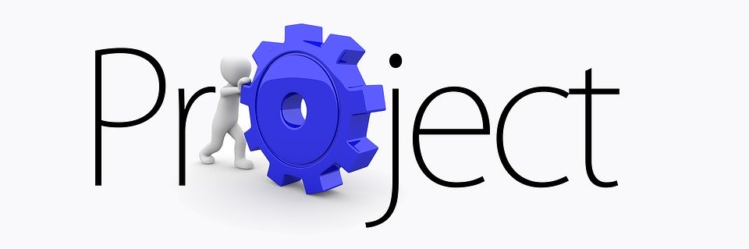
Your Project will be roughly 1500 – 2000 words or you could make a PPT. You will present this work in your first Sociology lesson. You will spend 2 weeks researching and completing this.
Pick a title that interests you, the focus area is INEQUALITY in Society.
Inequality is something that is looked at in all topics in Sociology A Level so it’s a good theme to start with..
- Is life fair? An exploration of inequality in society.
- Are women more likely to suffer poverty in the UK?
- If I am from an Ethnic minority group will I be at a disadvantage in society?
- C19 – Does it affect both the rich and poor equally?
Remember just pick one of the above questions to focus on.
General but useful websites for Sociology..
https://thesociologyguy.com/
https://facility.waseley.networcs.net/vle/Sociology.aspx
https://www.tutor2u.net/sociology
https://revisesociology.com/
Week one: Investigate Inequality on a general level. I want you to get a good understanding of what inequality is and how it may affect us in Society. You can use general websites and News articles to do this. Week two you can be more specific in your research.
- What is Inequality?
- What is the impact of Inequality upon Society?
Useful websites/ links
Understanding Stratification
https://www.youtube.com/watch?v=SlkIKCMt-Fs
Income Inequality
https://www.youtube.com/watch?v=Oj2LA8rEqQ4&fbclid=IwAR31zk0xFGMBRCAzg_E2LU7jkzgiyjyA9Rrp-QQEz49xJzxWes7JVpRib_I
Why life is not fair? I thought this example was very well done.
https://www.youtube.com/watch?v=4K5fbQ1-zps&fbclid=IwAR3PbZgQusZgYi67iC-3T-3kr4Z8qQRE3O6feOnUjvNeafR8CO84sq9IDB4

How economic inequality harms societies | Richard Wilkinson
https://www.youtube.com/watch?v=cZ7LzE3u7Bw&t=457s&fbclid=IwAR3Het5LCfcL4HJCczSgTVFf5h6hKt9HDVdnXNh4EYHIXwizYRa_sALhS_Q
Inequality in Education due to Coronavirus
https://www.theguardian.com/politics/2020/may/18/keeping-schools-closed-in-england-will-widen-educational-inequalities-study-ifs?CMP=share_btn_link
https://www.bbc.co.uk/news/business-56359863

I hope this all helps with your first part of research, you don’t have to use these sites if you find other suitable articles.

Week 2 Projects
Key Focus is INEQUALITY in society. This week try and find information relevant to your chosen question.
Recommended places to look at
TED Talks
BBC Podcasts
You can use these to search specific areas. Other things I have found this week are listed below and may help you. Please remember you can also use the general Sociology websites as shown in week one assignment page.
Ethnicity and C19
https://www.youtube.com/watch?v=S44OH7qKwTQ
https://www.tutor2u.net/sociology/blog/black-americans-dying-of-covid-19-at-three-times-the-rate-of-white-people?fbclid=IwAR0hQJrT47gqQuDGgzqBQI6MsAltEoRzMViat1CNLcDL_mVuvzSKvFavyKU
https://www.theguardian.com/world/2020/may/20/black-americans-death-rate-covid-19-coronavirus
C19
https://www.tutor2u.net/sociology/blog/nhs-coronavirus-bereavement-scheme-extended-to-low-paid-workers?fbclid=IwAR2ipKK1k78DGau_14sjoprgPLYjlIASzxBe6ayK6jII1mEp0b1NBuGKj-Y
https://www.theguardian.com/world/2021/jun/14/uk-health-inequalities-made-worse-by-covid-crisis-study-suggests
Gender pay gap
https://www.bbc.co.uk/news/uk-42580194?fbclid=IwAR1kBy4VKyV3u_HzPAGZrUAvkBencLWsjk_lsgUDrQI0sv8iEVhJ_IxTli0
https://www.independent.co.uk/life-style/women/gender-pay-gap-equal-pay-women-paid-less-motherhood-a8856121.html
Women in poverty
https://www.youtube.com/watch?v=Bhx3jKEwbFA&fbclid=IwAR1pD74LJt_eD6ixDWbFagyKXdZYqoTuYiyDWnhy6NESXVm6XaGaX_otHeA
https://www.oxfam.org/en/why-majority-worlds-poor-are-women
https://www.wrc.org.uk/women-and-poverty-during-the-pandemic
Ethnicity and impact of the killing of George Floyd
https://www.theguardian.com/us-news/2021/may/22/george-floyd-murder-change-across-world-blm
https://www.bbc.co.uk/news/world-us-canada-56270334
https://www.bbc.co.uk/news/newsbeat-52877803

Media
www.theguardian.com/education/sociology
www.nytimes.com/topic/subject/sociology
www.tutor2u.net/sociology/blog
www.soc.washington.edu/news

www.sociologysal.blogspot.com
www.gendersociety.wordpress.com

Useful Sites
www.creativesociology.blogspot.com
www.sociologylens.net
https://revisesociology.com/
https://www.tutor2u.net/sociology
https://www.aqa.org.uk/subjects/sociology/as-and-a-level/sociology-7191-7192
https://thesociologyguy.com/a-level-sociology/
Book for next year
https://napierpress.com/

