Core Maths: Summer Task

Introduction
There are a number of GCSE topics which will be relied upon during your early study of the Core Maths course. Section A of this Summer Task gives you an opportunity to practise some of these key skills and develop your understanding of any areas which you find challenging.

Wider skills
There are three overarching themes to Core Maths Level:
- Mathematical analysis
- Mathematical problem solving
- Mathematical modelling
In examinations m are awarded for your method and communication of your thinking: a final correct answer will usually only achieve part marks.
Section B of this Summer Task gives you an opportunity to demonstrate your starting point in developing these skills by solving a problem and presenting your solution in a mathematically concise way which is easy for anyone to read and follow.

Instructions
Answer each of the questions below on lined paper. Show your method for each question and underline your final answer.
While calculators are permitted in all Core Maths examinations, the majority of the questions below should be attempted without a calculator where possible as developing the speed and accuracy of your mental calculations will benefit you greatly in the time pressure of examinations.

Section A: Topic Questions

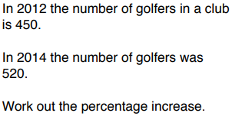 | 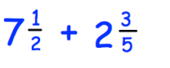
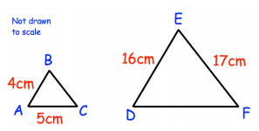 | 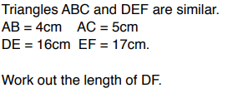
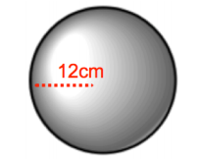 | 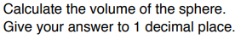
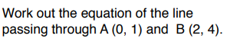 | 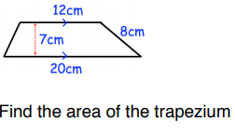
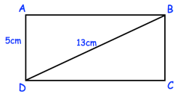 | 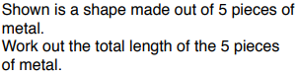

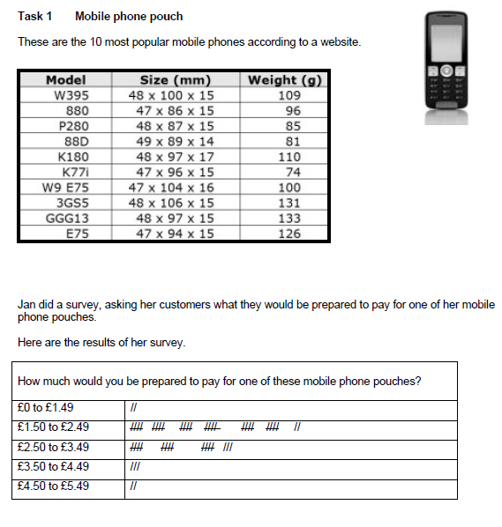
Section B: Problem Solving and Communication
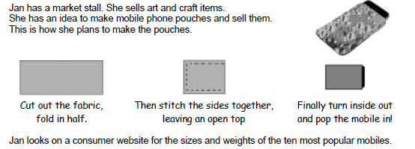

- What is the modal thickness for the mobiles in Jan’s list?
(1 mark)

- What is the modal width for these mobiles?
(1 mark)

- On average, how long are these mobiles?
Show and explain how you used Jan’s information to decide.
(3 marks)

- Draw full-size (on a separate piece of paper) the piece of fabric Jan needs to cut out for a pouch.
Give the dimensions of the piece of fabric.
Write down any working or assumptions that you use.
(5 marks)

- Jan buys very cheap pieces of fabric. These come in 1.6 m widths and are about half a metre in length. They cost 50p each. Jan has free use of a sewing machine. She can make a mobile pouch in about 10 minutes.
NOTE: The national minimum wage is about £6 an hour.
Roughly how much does the material and labour cost to make a single pouch?
(4 marks)

- Before starting to sell the pouches Jan does some market research.
She makes sample mobile pouches and asks some people what they would be prepared to pay for a pouch.

- Use the results of Jan’s survey to suggest what she should charge for a pouch and explain why.
(3 marks)

- How much profit would Jan make on each pouch?
(1 mark)

