Year 12 Unit 22 Investigating Sport and Active Lifestyle Businesses Summer Task

You have been employed as a social media marketing expert. Your employer has asked you to create a social media marketing campaign to promote their latest sporting services (e.g., fitness classes, physiotherapy etc) or products (trainers, clothes etc).
- You need to create a poster (e.g., Instagram advert) and/or a short video (e.g., tik tok) to promote your chosen product. You might want to include:
  - Description about the service or product
  - Price
  - Opening times
  - How to book/buy

- Complete the reflection log on the next page.

Please see some businesses below to help get you started:

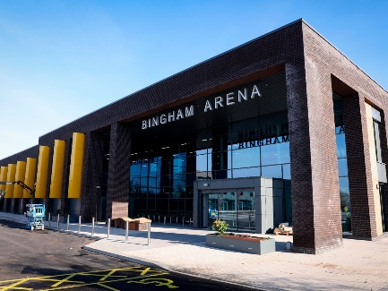

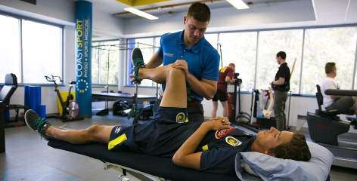

Reflection Log
- What does your chosen business do?
______________________________________________________________________________________________________________________________________________________________________________________________________________________________________________________________________________________________________________________________________________________________________________________________________________________________________________________________________________________________________________________________________________________________________________________________
- Who are their target customers?
______________________________________________________________________________________________________________________________________________________________________________________________________________________________________________________________________________________________________________________________________________________________________________________________________________________________________________________________________________________________________________________________________________________________________________________________
- Why did you choose this brand?
______________________________________________________________________________________________________________________________________________________________________________________________________________________________________________________________________________________________________________________________________________________________________________________________________________________________________________________________________________________________________________________________________________________________________________________________
- How does your marketing campaign meet the needs of the brand and appeal to the target market?
______________________________________________________________________________________________________________________________________________________________________________________________________________________________________________________________________________________________________________________________________________________________________________________________________________________________________________________________________________________________________________________________________________________________________________________________
- What information have you chosen to use within your marketing campaign and why?
______________________________________________________________________________________________________________________________________________________________________________________________________________________________________________________________________________________________________________________________________________________________________________________________________________________________________________________________________________________________________________________________________________________________________________________________

