
SUBJECT: Level 3 Mathematical Studies (Core Maths)

EXAM BOARD: AQA

Course Overview (Y12) | Paper 1  Analysis of data (sampling, calculating averages), Maths for personal finance (e.g. student loans, mortgages, interest rates and APR, income tax and National Insurance), Estimation and critical analysis of given data.  Paper 2  Critical analysis of given data and models, The Normal Distribution, Probabilities and estimation, Correlation and regression.
Useful websites | www.aqa.org.uk - specification, specimen papers.  http://www.mathcentre.ac.uk/ - support materials, free of charge. There are a variety of resources - self study guides; test yourself diagnostics and exercises; video tutorials; iPod and 3G mobile phone downloads; and case studies. Resources are available on-line, and may be printed or downloaded.  http://plus.maths.org/content/ - Plus is an internet magazine written by the Millenium Mathematics Project which aims to introduce readers to the beauty and the practical applications of mathematics.
Optional text book and reading list | 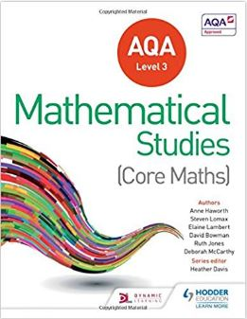  Mathematical Studies for AQA Level 3 (Core Maths)  Authors: Heather Davis, Andrew Manning, Dave Gale, Steve Lomax, Marc North, Anne Haworth, Ruth Jones, David Bowman, Elaine Lambert  Publisher: Hodder Education  ISBN-13: 978-1471863752  You will also require a Casio scientific or FX-991CW ClassWiz calculator. This will be available from school via Scopay at an approximate cost of £25

