**A Level English Language and Literature:**

*Over the next 2 weeks, you will research the gothic genre, where ‘Dracula’ fits within this genre, how context influences Dracula, finishing on a written task.*

**Week 1 - What is gothic fiction?**

Create a power point/mind map/short video/handout of your findings which are shaped by the bullet pointed questions below:

* What is gothic fiction? Define gothic fiction
* What are the characteristics of the genre and examples of these? Eg. Setting
* What is the history of the gothic genre? What has influenced the genre’s development?

This should be in your own words and you should summarise the ideas presented in the articles and videos below:

Read and make notes on the links below to help you answer the above questions in detail. You can also use AI to help you with this task.

<https://www.thetutorteam.com/english/how-to-study-gothic-literature-what-are-the-features-of-a-gothic-story/>

<https://www.youtube.com/watch?v=1wCmZoljqqU>

<https://www.nypl.org/blog/2018/10/18/brief-history-gothic-horror>

<https://www.bbc.co.uk/teach/articles/zvr9vk7>

**Week 2: Stoker’s inspiration and context**

Dracula was written by Stoker at the turn of the century and embodies Victorian fears about immigration, sexuality and the world ending.

Please make notes on the following sections:

**Xenophobia**

**Historical context**

**Religion vs Science**

**Anxiety and the vampire**

**Victorian medicine**

You could add slides to your existing ppt, or create a mind map, or illustrated infographic.

Use some of the following resources to help you:

<https://www.britishlibrary.cn/en/works/dracula/#:~:text=The%20most%20immediate%20answer%20is,refugees%2C%20dissidents%20and%20the%20persecuted>.

<https://www.sparknotes.com/lit/dracula/context/historical/victorian-science-medicine/>

<https://www.youtube.com/watch?v=2fV-j2wTn3Q>

**Final Task:**

* Using your research, and knowledge of how to analyse an extract from both GCSE Language and Literature as well as your research in the context relating Dracula, you should now complete the essay linked to the extract from ‘Dracula.’

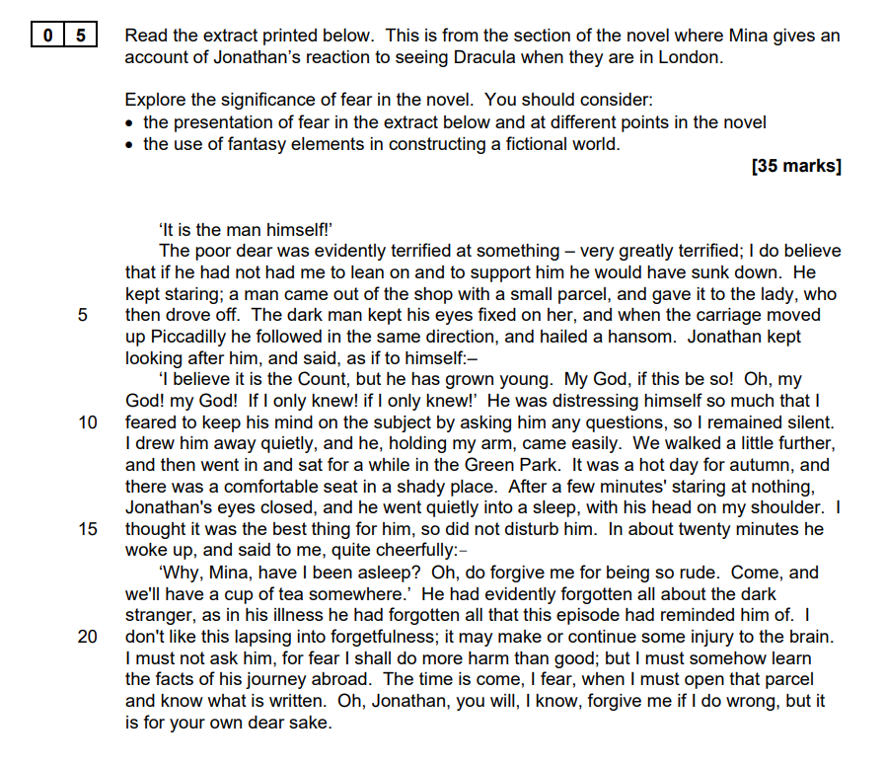

**Help box:**

Look at how potential illness/mental illness has afflicted Jonathan. How does the language portray this?

Link to the relevant context (from your research) which inspired this setting and Stoker’s intentions. The couple are back in London after Harker’s trip to Transylvania.

Use your knowledge of writing GCSE Literature responses, but apply the more specific language terminology below, looking for patterns of language.

**Terminology which may be of relevance in this extract:** noun-phrases, plural pronouns, semantic field, metaphor, simile, adverbs, verbs, thought verbs, lists, repetition, simple sentence, and symbolism.

**Summer reading:**

Throughout this course, you will be studying *Dracula* by Bram Stoker, *A Streetcar Named Desire* by Tennessee Williams, and *The Great Gatsby* by F. Scott Fitzgerald, but to name a few. It is recommended that you pre-read these texts so you have time to explore the plot and characters at your own pace before the course begins.