Year 12
College Induction Booklet

Contents:
- Welcome from  - Mrs Mordue (Head of College)  - Mr Elliott (Head of Y12) | 3
Toot Hill 6th Form College Ethos  - Dare to Know  - Leave your Legacy | 4
Toot Hill 6th Form College Standards: Attendance  - Policies and procedures | 5
Toot Hill 6th Form College Standards: Other  - ID Badges and Lanyards  - Dress Code  - The Building - The Study Rooms, The Curve, College Classrooms | 7
Toot Hill 6th Form College Disciplinary Procedure  - Serious offences – Drugs, Alcohol, Violence, Bullying and Other.  - Other offences – E.g. Attendance, Behaviour/Attitude, Homework, Private Study | 8
Toot Hill 6th Form College Private Study  - Policies and procedures | 10
Toot Hill 6th Form College Mentor Programme  - Expectations  - Scheme of work | 11
Toot Hill 6th Form College Enrichment  - The Toot Hill College Passport  - Other enrichment opportunities | 12

Who’s Who? Contact Details  - The College Leadership Team  - The College Mentor Team  - The Toot Hill College Students’ Union  - Who to email, when, and how | 13
Where is … ?  - Map of College building (The Suthers Building)  - Map of Toot Hill Lower School | 15
When does … ?  - Normal timetabled day  - Normal timetabled week (Y12) | 19
Mental Health and well-being | 19
Overview of Mentor Period | 22
Scholarship agreement and off-site consent form | 24

Welcome to Toot Hill 6th Form College!

Welcome from Mrs Mordue – Head of College:

I am delighted to welcome you to Toot Hill 6th Form College, and am looking forward to getting to know you and witnessing your development into young adults over the course of your next two years with us. At Toot Hill 6th Form College we aim to offer you all an ambitious curriculum, alongside an abundance of opportunities which will enable you to grow into confident, well-rounded and happy adults. Above all, this is due to the firm professional relationships established between staff committed to their students, and students committed to their studies. I look forward to working with you over the course of the next two years, and to helping you discover and work towards achieving your future aspirations for life after Toot Hill 6th Form College.

Welcome from Mr Elliott – Achievement Director for Year 12:

In my role as Achievement Director for Year 12, my main responsibility is ensuring that you are happy, supported and have every opportunity to be successful during your time at Toot Hill 6th Form College. I am looking forward to working with you over the course of the next two years; this is an exciting time in your life when you will be making decisions and choices that will shape your future and allow you to go on to achieve your full potential after College. We are committed to ensuring that you all receive the support you need to access the wealth of opportunities available to you here.

Toot Hill 6th Form College Intent:
Our Personal Development Curriculum has been carefully curated to welcome our new students into our sixth form college community so that they are sensitively challenged to think about adult issues. Through this, our students will be encouraged to engage with and challenge perspectives on potentially divisive issues such as prejudice and morality to establish what they stand for by the end of their time in Toot Hill Sixth Form College. Students are mentored by our expert tutor team who deliver an ambitious personal development curriculum in an age appropriate manner and through this programme they are encouraged to take responsibility, lead their learning and make the right steps to be informed. The vertical tutor groups help to foster the close community feel of College, whilst encouraging our Year 13s to lead quality conversations and debates which provide a model for Year 12 as to how to deal with sensitively, mature themes.
As they begin the next phase of their journey, students will be introduced to our sixth form college ethos ‘Sapere Aude’ or ‘Dare to Know’ which encourages both freedom of thought whilst also challenging students to equip themselves with knowledge that goes beyond the curriculum. This ethos lies at the very core of our ambition for our students and will encourage them to shape their own identities and beliefs through being inquisitive and ambitious to learn whilst promoting similar values to others, modelling this to the younger members of the Toot Hill community. We will explore the way our students use language to articulate concepts and constructs such as masculinity and gender and invite them to critique the representations of these in the media and within their social groups. In this important transitionary period where our students are approaching adulthood, students will be encouraged to develop their understanding of diversity as they meet new students from a range of schools and backgrounds, appreciating the ways in which our differences, as well as our similarities, provide new perspectives and enrich our understanding of others.
In Year 12 we choose to focus on scholarship skills in the first half term followed by keeping safe in the second, this includes mentorship on making the right choices through topics such as drugs, driving and sexual health. In Year 13 we put a greater focus on serving the school; this is embodied by our Student Union who are sophisticated communicators of the students’ beliefs and work on enacting our other strand of our ethos ‘leave your legacy’ through using student voice as a vehicle for change. The Student Union Representatives are ambassadors for our school and are carefully selected for their inspiring and relatable characters. All of our college students are encouraged to serve the school through interactions in lower school lessons and the community through charitable events such as the Tea Dance and the Infants’ Christmas Party.
Our ethos ‘Dare to Know’ prompts our students to have a thirst for knowledge and students are actively encouraged to take responsibility for their learning by reading widely, joining subject societies and engaging with our year long scholarship programme in tutor time. We expect all students to be passionate about this challenge that they have chosen to embark upon and we will encourage our students to explore new concepts and challenge themselves to think and explore knowledge beyond the curriculum. Subject representatives, the leaders of our subject societies, will encourage this deep appreciation for their subjects and share their passion for learning which will ensure College students have an understanding of the discipline and its place within the world whilst becoming role models for younger students as they endeavour to enrich their understanding through engagement with the lower school community. Our students will be encouraged to be reflective of these experiences as they begin to seriously consider what the future holds for them beyond secondary education. Guided by our mentors towards ambitious destinations which include the most prestigious Universities and employers, or aspirational apprenticeships, our students are set on a pathway to success.
Our fundamental value of providing an ambitious curriculum is complemented by our guidance and support to encourage our students to have ambitious aspirations for their futures. Their engagement and our dedication will help them to secure their dream futures allowing them to continue to leave their legacies in real world professions and to make a difference to the world around them. Toot Hill Sixth Form College students will leave us embodying the ultimate Toot Hill learner. They will be thinkers and contributors with deep appreciation of: others, of varied perspectives and of art and culture who can appreciate and grow from diverse experiences. The ultimate aim is for them to ‘leave their legacy’ on the College certainly, but more importantly, on the rest of the school community – appreciating what it means to empower others also. This legacy will live on as our college alumni return to the Toot Hill community to enrich our students’ knowledge and understanding with their experiences of the wider world.

Toot Hill 6th Form College Standards:
Attendance

Toot Hill 6th Form College Attendance and Absence Procedure:
All students at Toot Hill College are expected to attend morning registration every day, and all their timetabled subject and private study lessons.
Students will also have a compulsory personal development lesson on Tuesday period 2 and a rolling mentor period each week. You are expected to attend these lessons every week as part of our commitment to developing your character, your understanding of future pathways and destinations, and ensuring you receive the full RSE curriculum.
Attendance to all sessions is crucial for ensuring that you achieve your full potential while with us. In the case of unavoidable absence, we have a strict attendance and absence procedure:

Absences known about in advance:
For unavoidable absences known about in advance, you must collect a ‘Leave of absence’ form from the College Reception, which must be discussed with, authorised and signed by a parent/guardian and a member of the College Leadership Team, before being returned to the College Secretary.

Absences on the day:
If you are too ill in the morning to attend College on that day, please ensure a parent rings and speaks to the College Secretary on 01949 863072 or leaves a message. Alternatively, your parent can email the reason for your absence to contact@toothillcollege.co.uk
If you fall ill during the day at College, you will need to speak to a member of the College Leadership Team who will authorise your absence for the remainder of the day by completing and submitting a ‘Leave of absence’ form.

 | Who? | What happens?
Step 1 | College | During the day, the College secretary will check a student’s overall attendance in timetabled lessons and mentor period for that day.  In the case that a student has unauthorized absences in their timetabled lessons and mentor periods, parents will receive an email, phone call or text to notify them of this issue.  The College team will then call or email on Fridays to discuss if no reasonable explanation for the absence has been provided.
Step 2 | Parent | If there are reasons for their absence which have not previously been communicated to us, please contact us by the end of the day the following Monday on 01949 863072 or contact@toothillcollege.co.uk

If we have not received contact from home explaining any further context for the unauthorised absences, or in the case of poor attendance, we will intervene using the following system:

Level(s) | Examples | Actions
General | Poor attendance  Lateness | The student attends a meeting with their mentor to explain their attendance and a letter is sent home regarding the reason/outcome of the meeting, including Year 12 consequence of not continuing into Yr13, Year 13 cost of exams.
Level One | Repetition of Level 1  Continued failure to follow 6th  Form Attendance Procedures | If the pattern of poor attendance/punctuality continues, another meeting will be arranged with the student and mentor to discuss the issue.  Appropriate targets will be set and the student will be recorded on Level 1 additional 6th Form contract.  The student’s attendance/punctuality will then be monitored closely for two weeks. A letter is sent home with a copy of the contract and any targets outlined including Year 12 consequence of not continuing into Yr13, Year 13 cost of exams.
Level Two | Repetition of Level 1 and/or 2  Continued failure to follow 6th  Form Attendance Procedures | If no improvement in seen within the two weeks, a meeting will be arranged with the student and the 6th Form leadership team.  A level 2 additional 6th Form contract is drawn up and copy sent home, including Year 12 consequence of not continuing into Yr13, Year 13 cost of exams.
Level Three | Repetition of Level 1 and/or 2/3  Continued failure to follow 6th  Form Attendance Procedures | Year 12 - if despite all intervention work, no improvement is evident, a meeting will take place with parents and student about the concern/risk of the student’s 6th Form place. Students may be placed on a Level 3 additional contract.  Year 13 - if despite all intervention work, no improvement is evident, a letter will be sent home requesting payment for exams. (Prior to free removal from exam entry – Mid-March)

Removal of the privilege to go off site will be revoked if a student is unable to meet attendance expectations.

Toot Hill 6th Form College Standards:
Others

Toot Hill 6th Form College ID Badges and Lanyards:
In order to ensure that all students are safe on site, all students and members of staff are assigned ID badges at the beginning of each year in September. These ID badges must be worn by students and staff at all times.

Toot Hill 6th Form College Dress Code:
At Toot Hill College we have a professional dress code for our learners, which has been designed to reflect the values of hard work and professionalism we instil in all our students.
The dress code requires students to attend College in smart/casual clothing, which excludes stressed denim, short shorts, low-cut (crop) tops, leggings and sports wear.

Toot Hill 6th Form College Disciplinary Procedure
Serious Offences – No Tolerance Policy:
For the following offences, Toot Hill 6th Form College has a ‘No Tolerance Policy’:
- The use/sale or knowledge of illegal drugs on the College site.
- The use/sale or knowledge of alcohol on the College site.
- The possession or knowledge of any form of weapon on the College site.
- Violence or threatening/intimidating behaviour to other students or staff.
- Any other misdemeanour which seriously threatens the wellbeing or safety of another student or member of staff.
A ‘No Tolerance Policy’ means that:
- While the matter is under investigation the student will not be permitted onto the College site.
- If the student is found to have committed one of the offences above, they will not be allowed to remain on the College roll as a student here.

Other Offences – Disciplinary Procedure:
For other offences that do not threaten the wellbeing or safety of another student or member of staff, Toot Hill 6th Form College has the following disciplinary escalation procedure:
Occurrence: | If in lesson time: | If outside of lesson time: | Student record:
C1 | - Verbal warning | Verbal warning. | N/A
C2 | - Subject teacher to phone home |  | Logged on Bromcom as C2
If there is a repeated pattern of C2s, the following sanctions may be applied:
Behaviour continues in lessons  Continued repeat offences | - College detention with Head of Year |  | Phone call/email home.
 | - College detention with Head of College |  | Phone call/email home.
 | - Formal meeting with parents and student. |  | Formal record of meeting.
 | - One day inclusion. |  | First formal warning.
 | - Two/three day inclusion. |  | Second formal warning.
 | - Fixed-term exclusion. |  | Final formal warning.
Final outcome | Permanent removal of student from roll.

Please note that if the offence is serious enough, it may need to escalate through these stages at a faster rate, or begin at a more serious sanction.

Toot Hill Sixth Form College e-Safety and Acceptable Use of ICT Policy

All students at Toot Hill Sixth Form College must be aware of the code of conduct surrounding e-safety and ICT usage. This includes devices brought in from home including mobile phones, laptops and tablets.
All students are responsible for their own behaviour when using the internet at all times. Use of technology within the Sixth Form College must be safe, responsible and legal. Any misuse of the Internet will be dealt with as per the Sixth Form College’s disciplinary procedure.
Students must carefully consider the content that they access and share while using the Internet. They must be considerate when contacting others using the internet.
Students are not permitted to:
- Send, search for or display any content which is deemed offensive, including messages and pictures of an obscene, racist or fundamentalist nature.
- Harass, insult or attack others. This includes cyberbullying.
- Damage computer equipment or computer networks.
- Violate copyright laws.
- Attempt to access another student or member of staff’s account.
- Use proxy websites to access sites filtered on the school network.
Any student who receives content which violates one of the above rules, is subject to abuse or bullying online or knows of any incidents which break the above rules must report this to a member of staff.
Electronic Items
Students are responsible any electronic equipment that they bring onto the Sixth Form College site, including mobile phones, laptops and tablets. The Sixth Form College accepts no responsibility for loss, theft or damage.
Mobile phones are not permitted to be used in any lesson or other Sixth Form College occasion such as assemblies. Mobile phones must not be used to bully, harass or insult another person through use of voice calls, texts, emails, social media, photographs or videos. The use of laptops or tablets in lessons is at the discretion of the member of teaching staff. Students should speak to a member of the college team if they need to use electronic items for a specific academic learning need.
Mobile phones or other electronic items must not be used to photograph or record any other member of the Sixth Form College community without their express permission. Any permitted photographs or videos must be used only in accordance with the above rules.
Staff reserve the right to ask students to hand over their phones during lessons if students persistently have them out in lessons. The phone will be secured in the College Secretary’s office and returned at the end of the day following a conversation with a member of the college team.
Student Email
Students should only use their Sixth Form College supplied email to contact staff and students. Students are responsible for the content of their emails, which should adhere to the above rules. Students should ensure that their emails are appropriately written, adhering to a professional format.

Toot Hill 6th Form College Private Study
What is private study?
A Level and Level 3 Vocational Courses simply require a higher level of independent learning by students than Level 2 GCSE courses.
In Year 12, you will have an additional 6 periods of private study on your timetable.
Each week is broken down into a possible 29 periods of 55 minutes each.
 | Year 12 | Year 13
Timetabled lessons | 18  (3 subjects of 6 periods each) | 18  (3 subjects of 6 periods each)
Timetabled private study periods | 6 | 6
Timetabled weekly mentor period | 1  (Monday Period 1) | 1  (Monday Period 1)
Total: | 25 | 25

As a guide, the minimum number of hours of independent study a student should complete outside of lessons is 18 hours to be successful.
They should expect 1hr ½ per teacher per week of home learning equating to around 9 hours work. It is expected that students will complete an additional 9 hours of practice and revision independently.
What are the expectations for private study?
During your timetabled private study periods you must:
- Go to the atrium for independent silent study
- Use the curve for working in a small group

Toot Hill 6th Form College Mentor Programme
Why is the mentor programme so important?
At Toot Hill 6th Form College we believe that your education should be broader than just the three Level 3 courses you are studying. During your time with us, you will all become young adults, and we want to support you on this journey by equipping you with key life skills that will aid you after College.
In order to do this, Toot Hill 6th Form College runs a ‘mentor programme’, where students work each week with their mentor on an aspect of the RSE and personal development curriculum, which aims to support you during your time here as well as help you pick up knowledge and develop skills that will be useful when you leave us.
Finally, it is crucial that you attend your mentor periods in order for your mentor to get to know you properly. This helps them to support you during your time here. It is also your mentor that will write your final reference for any university/apprenticeship or employment references you will need for your next destination – they will not be able to write these for you if they don’t know you!

When is the mentor programme?
Each week, you have a compulsory timetabled period with your mentor where we will deliver the RSE and personal development curriculum.
This period will take place on Tuesday period 2 every week.
It is compulsory for all students to attend, and attendance is monitored closely to these sessions.
Additionally, you will have a rolling mentor period each week where you will focus on ‘my scholarship’ and ‘my futures’ curriculum. Again, this is compulsory.

What if I don’t attend the mentor programme?
The Toot Hill 6th Form College Ethos was made clear at every stage of the application cycle – we expect all students to dare to know, going beyond the curriculum to broaden their perspectives as part of our personal development curriculum. We want our students to develop a strong understanding of adult themes through the RSE curriculum we deliver to prepare them for life beyond Toot Hill 6th Form. Additionally, mentors use this time to guide our students towards ambitious destinations which include the most prestigious Universities and employers, or aspirational apprenticeships.
If you choose not to attend a mentor programme session without reason, this absence is sanctioned in the same way as missing a timetabled lesson for one of your courses.

What will we cover on the mentor programme?
Please see the end of the booklet for our overview.

Toot Hill College Enrichment Opportunities

Toot Hill 6th Form College Development:
Alongside the academic programmes we offer, Toot Hill College is proud to be able to offer a substantial menu of enrichment and extra-curricular activities. We particularly emphasise the benefits of student volunteering and accredit this within the Toot Hill College. All students have the opportunity to complete a programme of voluntary work within and outside of school alongside work experience.

Other opportunities:
Further to this students will get the opportunity to engage in a number of other enrichment opportunities such as EPQ (extended project), Core Maths, DoE, STEM, Young Enterprise, Sports Leaders, MOOCs, Level 1 BSL online, and the Student Union.

Toot Hill College – Who’s Who?
Your College Mentors:
Your College Mentor is the first point of contact for you on any issue – they will be the key person supporting you during your time at Toot Hill College.
Your mentor will offer guidance and support during your time here through compulsory morning registration time and your compulsory weekly mentor period on a Monday morning.
The Year 12 College Mentors this year are:
Mentor | Subject specialisms: | Contact email address:
Ms. Revagliatte | Psychology  Health and Social Care | grevagliatte@toothillschool.co.uk
Ms A. Bell | Media Studies | abell@toothillschool.co.uk
Mr Sandiford | Physics | dsandiford@novaeducationtrust.net
Mr Rogers | Business and Economics | amoreman@toothillschool.co.uk  mrogers@toothillschool.co.uk
Mr R Walters | D.T | rwalters@toothillschool.co.uk
Ms. Britton | Drama | mbritton@toothillschool.co.uk
Ms L. Graham | Languages | lgraham@toothillschool.co.uk
Mr Law | History | Jlaw@toothillschool.co.uk
Miss Starkey | History and Politics | fstarkey@toothillschool.co.uk
Miss Bishopp | Languages | hbishopp@toothillschool.co.uk
Miss Perkins | English Literature | sperkins@toothillschool.co.uk
Mrs White | D.T | lwhite@toothillschool.co.uk
Mr Lang | Physics | jlang@toothillschool.co.uk
Mr Armann | Maths and Computing | parmann@toothillschool.co.uk
Ms Hale | Geography | TBC
Ms McCabe | English/PE | EMcCabe@toothillschool.co.uk
Mr Vivian | Business and Economics | tvivian@toothillschool.co.uk

Your Head of College:
Your Head of Year is Mrs Mordue. She will be working closely with you and your mentors over the next two years to help provide support and guidance during your time here.
cmordue@toothillschool.co.uk
The College Leadership Team:
The wider College Leadership Team are also here to help you during your time here. They are based in the office next to the Study Atrium and you can also see them if you have any concerns. The main roles and responsibilities of the members of staff on the Toot Hill College Leadership Team are:
Staff member | Role | Email
Ms. Coates | Achievement Director of Year 13 | pcoates@toothillschool.co.uk
Ms. Challoner | Pastoral Lead + Designated Safeguarding Lead | mchalloner@toothillschool.co.uk
Mr. Elliott | Achievement Director – Year 12 | aelliott@toothillschool.co.uk
Mr .Lawrence | Destinations Lead | slawrence@toothillschool.co.uk
Mel Hopper | College support | contact@toothillcollege.co.uk
Ms Warren | Assistant SENCO for Toot Hill School and College | rwarren@toothillschool.co.uk

The Students’ Union
In Summer Term each year, a new Students’ Union is elected to represent the students at Toot Hill College. All officers in the Students’ Union are in Year 13, and have a specific role in College. The Students’ Union 2022 to 2023 are:
SU Presidents: Bella Hart and Owen Rushin
Treasurer – James Williamson
Diversity Officer – Sydney Adams and Sri Hrudya Kolli
Wellbeing Officer – Libbie Maddock and Dell Goodman
Extra-curricular Officer – Tom Barr
Academic Officer – Yasmin Rahman
Social Management Officer – Izzy Bushen
Events Officer – Kate Bradley
Head of SU website – Luka Hosak Davies

Who should I email, when, and how?
It is usually better to see someone in person if you can, as schools are very busy places and if staff are teaching they may not be able to pick up an email until a significant time after you have sent it.
If … | The best person to contact is …
… I need advice on something in a lesson or something to do with a homework assignment. | Your subject teacher either via email, TEAMs or in person.
… I am worried or confused about something in College and would like some support and advice. | Your mentor (first).  Your Head of Year.
… I am seriously concerned about the safety or wellbeing of myself or another student in College. | Ms. Challoner – Pastoral Lead and Designated Safeguarding Lead
… I want to discuss / inform someone or have a query about my attendance or the College bursary. | Mel Hopper College Secretary
… I have an idea or suggestion for something I would like to see happen in College. | Your Students’ Union

Where is … ?
Toot Hill Lower School Site Map

Leisure Centre & Sports Hall
MFL
History, P&E
Geo
English
ICT
Astroturf
D&T
Learning Lounge
Sci Block
SC1, SC2 & SC6
Dining
Room
Reception
Concert Hall
NE Dining
SS1/SS2
Hub
Assessment Centre
Maths
Art
Drama
Music
Business
Little Sch
Beach Hut
To College
Bus
Park
Path
Out of
bounds
3
9
Steps
Field
Fence
10
8
5
4
7
6
1
2

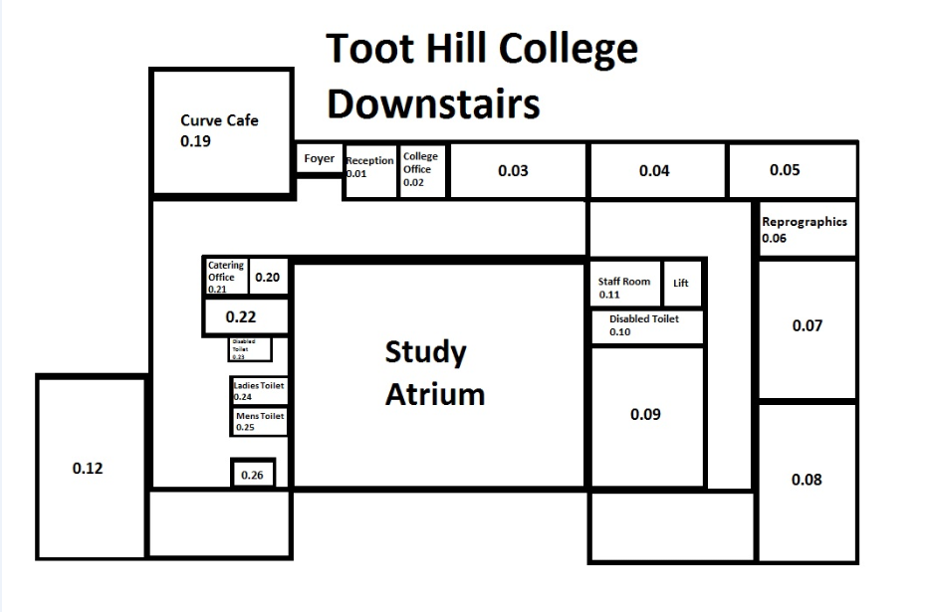

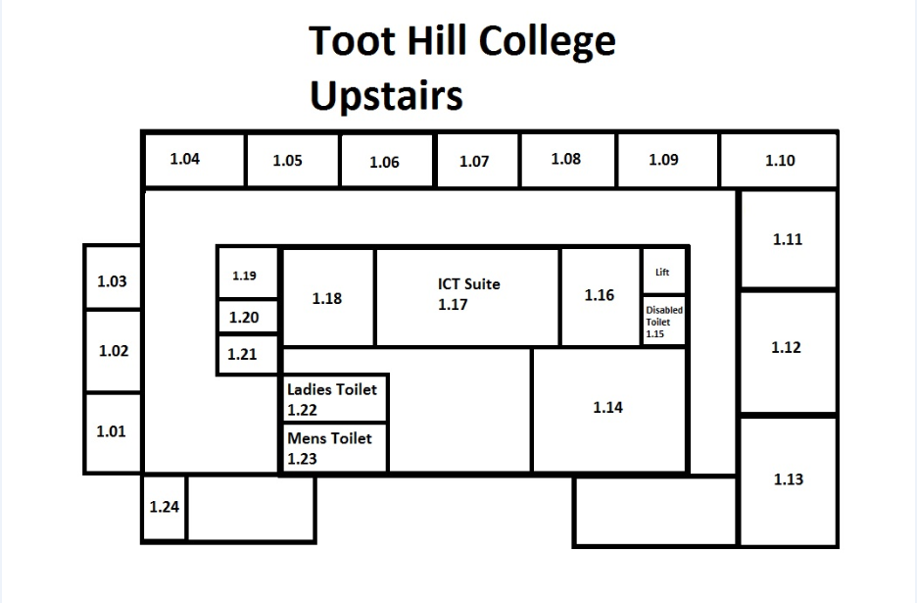

When does …?
Toot Hill 6th Form College timetable of the day:
8.25am – 8.45am | Compulsory registration in mentor groups.
8.45am – 9.40am | Period 1
9.40am – 10.35am | Period 2
10.35am – 10.50am | Break
10.50am – 11.45pm | Period 3
11.45pm – 12.40pm | Period 4/Lunch
12.25pm – 1.15pm | Period 5/Lunch
1.15pm – 2.10pm | Period 6
2.10pm – 3.00pm | Period 7

- Please note that on a Friday, College – as per the lower school – ends at 2.10pm, at the end of Period 6.
- PSHE mentor period is Tuesday period 2.

Mental health and well-being:

Shelly Challoner is our pastoral lead in College and our designated safeguarding lead. Shelly runs a drop in session twice a week for students though students are welcome to speak to their mentor, or any one of the college team. To help parents and students find additional support, please see the links below, though we will guide students through these if external help is needed:
External safeguarding concerns
Multi agency hub line 0300 500 80 80
Parent Advice line for Support - 0115 854 2299 (Family Health Team)
General Support
https://www.beusupport.co.uk/
https://nottalone.org.uk/?a=yp

There are also helpful links for further advice
Online safety:
The DfE guidance and advice can be found at:
https://www.gov.uk/government/publications/preventing-and-tacklingbullying
Websites and Phone Numbers
www.nspcc.org.uk
www.ceop.gov.uk
www.ikeepsafe.org
www.saferinternet.org.uk
www.thinkyouknow.co.uk
www.childnet.com
www.digizen.org
www.kidsmart.org.uk

Childline www.childline.org.uk
Comforts, advises and protects children 24 hours a day and offers free confidential counselling.
Phone 0800 1111 (24 hours) Chat 1-2-1 with a counsellor online
Kooth www.kooth.com
This is an online counselling and emotional well-being platform for children and young people, accessible through mobile, tablet and desktop and free to access.
Young minds www.youngminds.org.uk
Advice and information about young people’s mental health including information on CAMHS and what the next steps to seeking support are.
Health for Teens www.healthforteens.co.uk
Offer a great content and of your health, from sexual health to your feelings, growing up, lifestyle and much more.
Samaritans www.samaritans.org
24 hour confidential listening and support for anyone who needs it. (Adults included.) Phone 116 123 (24 hours) Information and support for mental health issues
Self Harm Incl Eating disorders
Harmless- www.harmless.org.uk
https://calmharm.co.uk/
B-eat www.beateatingdisorders.org.uk
The UK's eating disorder charity. They have online support groups and a helpline for anyone under 18. Phone 0345 634 7650 (4pm – 10pm 365 days a year) Email fyp@b-eat.co.uk
The Mix www.themix.org.uk
Information, support and listening on EVERYTHING for young people
Phone 0808 808 4994 (24 hours), get lots of support online
Drugs and alcohol
Frank www.talktofrank.com
Confidential information and advice about drugs and substance abuse, whether it's for you or someone else. 0800 7766 00 (24 hours, won't show up on your phone bill)
LGBT
Stonewall www.youngstonewall.org.uk
The UK charity for gay, lesbian, bisexual and transgender people and their allies. They offer information, advice. Phone 08000 50 20 20
Nottingham LGBT switchboard
Nottingham chartity offering advice for LGBT and questioning, people, their friends & family. Phone line open 7-9.15pm Mon-Fri 0115 934 8485.

Brief overview of the mentor period and personal development curriculum: | Year 12 mentoring | Year 13 mentoring | Personal Development Mentor period
Half term 1 | My Scholarship: Learning to Learn | My Future: applying for UCAS, apprenticeships and careers  My Scholarship: How to revise | Healthy relationships
Half term 2 | My Scholarship: How to Revise | My Future: applying for UCAS, apprenticeships and careers | Health and well-being
Half term 3 | My Scholarship: Super-curricular focus | My Scholarship: reflections on mocks and academic mentoring | Keeping yourself safe and happy
Half term 4 | My Scholarship: Super-curricular focus | The World I am going into: preparation for living independently | What do I Stand For?
Half term 5 | My Future: Unifrog focus – researching your next steps | My Scholarship: revision and academic mentoring | The World Around Me
Half term 6 | Revision and preparation for mocks + post mocks reflection. |  | My Future: Destinations

A more detailed plan can be found on the college website

Reminder of contact details:
Email: contact@toothillcollege.co.uk
Phone: 01949 863072

Scholarship agreement for Toot Hill 6th Form College Students

In order to succeed at Toot Hill Sixth Form College, students must fully commit to their studies. The Sixth Form College will support all students as necessary, however students must take responsibility for their own learning. Below are the expectations of all students:
- Achieve a minimum 95% attendance. Poor attendance may result in your withdrawal from courses and external examinations and could result in you paying your own examination entry fees.
- This includes
- Full attendance during timetabled lessons and 6 Private Study sessions
- Inform the College before 9.30 am each day, if you are unable to attend, and this is to be confirmed by parents a.s.a.p
- Inform the College of ‘foreseen absence’ in writing by completing a leave of absence form.
- Arrange all doctor/dentist appointments, driving lessons/tests after 3.30 pm.
- Be punctual to all lessons/exams/meetings/briefings, with the correct equipment and any preparatory work completed.
- Meet all deadlines set by your teachers and submit coursework on time.
- Respond on recommendations made by teaching staff to improve the quality of your work and your performance in your subjects.
- Make effective use of lesson and private study time so that you remain up to date on content. We expect a minimum of 16 additional hours independent work per week.
- Work closely with your mentor to broaden your skills and support the monitoring of your progress. This includes attending and engaging with the Personal Development Programme through mentor period sessions.
- Ensure that part time work does not exceed 12 hours per week, interfere with your studies and does not start before 5 pm on weekdays.
- To work quietly and independently outside of lesson time in the Atrium during your study periods where no food/drink, apart from bottled water, is permitted.
- Adhere to the Sixth Form College’s dress code.
- Observe the Sixth Form College’s policy on drugs, alcohol and smoking.
- Adhere to the Sixth Form College’s policy on e-safety and ICT use.
- Behave in a safe and appropriate manner in the car parks at all times, as both drivers and pedestrians.
- Behave in a safe and appropriate manner at all time when off-site conducting independent research or representing the sixth form college.
- Understand that if we are concerned about your health and wellbeing, whilst on roll at the college we will contact parents/carers.
Please consult the sixth form college’s behaviour code of conduct for more information on points 2, 10, 11 and 12, which can be found on the sixth form college website.
Where a student finds it difficult to meet the requirements of the Toot Hill Sixth Form College Learner Agreement, and following consultation with their mentor and subject teacher(s) they will be referred to the Leadership Team who will undertake additional work with the student to address the issues identified. Where students continue to neglect their commitment to be a valued member of Toot Hill, a meeting will be arranged with parents/carers.

Name of Student (please print in capitals) _________________________________________________
Signature ____________________________________________ Date _________________________

Name of Parent/Carer (please print in capitals) _____________________________________________________________________
Signature __________________________________________________________ Date ______________________________________

Car Park Agreement
If you are driving to college and parking on site, please be aware that this is open to the public and the highway code applies. CCTV does not cover all areas. Therefore to help our college secretary with any parking issues which arise, can we please ask that you add your registration number, make and model below:
Registration: _____________________
Car make/model: ___________________________
Colour: ________________________________
MEL PLEASE ADD THE PERMISSION to go into BINGHAM here!!!

